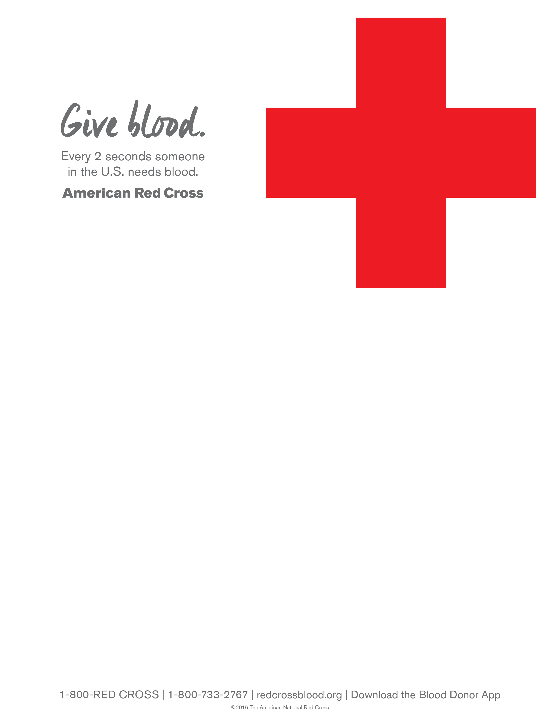

**You are Invited to the**

**Newport Beach City Employee’s Blood Drive**

**Monday, January 14, 2019**

**9:00am to 3:00pm**

**Location: Newport Beach Civic Center**

**Civic Center Community Room**

**100 Civic Center Drive, Newport Beach, 92658**

**To schedule your donation appointment,**

**Contact Laura at the Red Cross at**

[**laura.rudd@redcross.org**](mailto:laura.rudd@redcross.org) **or call (949)439-0551**

**Or sign-up on-line at** [**www.redcrossblood.org**](http://www.redcrossblood.org)

**Use sponsor code: NBCivicCenter**