BALBOA ISLANDS SEAWALL REPAIR 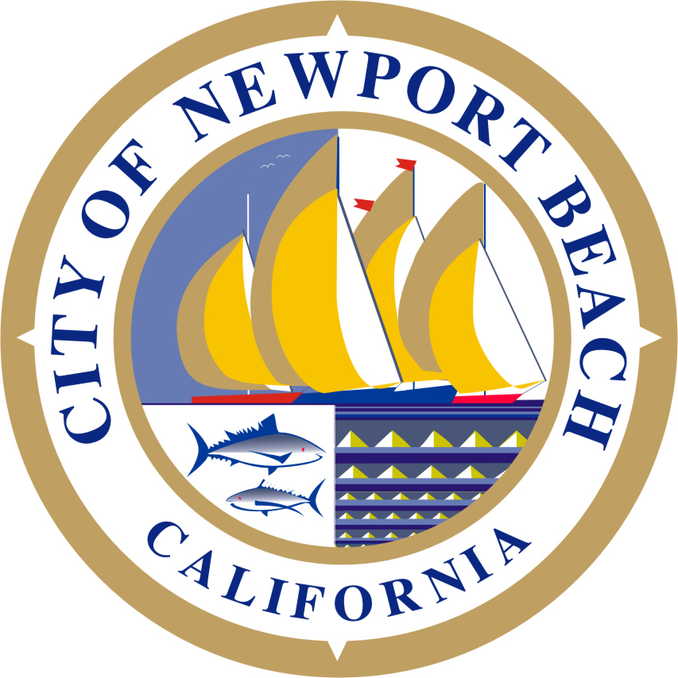
Frequently Asked Questions
April 26, 2013

The City of Newport Beach is considering the need to rebuild the deteriorating seawalls around Balboa Island and Little Balboa Island (Islands) possibly increasing the height of the wall by an incremental amount. This project is deemed necessary to provide structural integrity to the seawalls protecting the Island, as well as addressing projected sea level rise and protecting the islands from future flooding.

This brochure provides some answers to Frequently Asked Questions about the need for new seawalls and some possible approaches that could be taken to provide safety from flooding. Outreach to the Islands’ community will continue throughout the life of the project.

Seawall Condition, Seawall Height and Flood Risk
- How old are the seawalls around Balboa Island and Little Balboa Island (Islands)? What is their projected useful life?
The seawalls were built in the 1920’s and 1930’s so the seawalls are between 75 and 85 years old. See the attached figure. More recently, a cap has been added to the bulkhead beam on some portions of the seawall.

These seawalls have performed well but are beginning to show their age. Tie-rods have corroded and no longer acting to restrain the seawall. The City has been spending an increasing amount of funding in the recent years to repair and seal cracks. The walls are estimated to have between 10-25 years of remaining useful life.

More information can be found regarding the condition of the in the seawalls in a recent assessment report prepared by City entitled “Balboa Island Seawall Final Report”, April 1, 2011 which is posted on the City’s website: http://newportbeachca.gov/index.aspx?page=1822 (Scroll down to the bottom of the page.)

- Are the seawalls around the Islands high enough to provide adequate flood protection?
Some segments of the seawall around Balboa Island are not currently high enough to accommodate extreme high tides and waves and are periodically overtopped. (See attached photo.) If we witness additional sea level rise, longer segments of the existing seawall around Balboa Island will be subjected to future overtopping resulting in more frequent flooding over larger areas on Balboa Island. The Little Balboa Island seawall is somewhat higher than the Big Island due to a project built in the late 1980s that raised the cap. South facing sides of both islands are more susceptible to periodic overtopping from wave run-up through the harbor jetty due to storm surge.

- What are the existing top-of-seawall elevations?
The attached figure shows existing top-of-wall elevations around the Islands. The table below summarizes the existing top-of-wall elevations. The table below provides general elevation information.
Balboa Island |  | Little Balboa Island
North Side | 7.7-8.3’ | North Side (same as East side) | 8.6-9.1’
East Side (Grand Canal) | 8.5-8.7’ | West Side (Grand Canal) | 8.5-8.6’
South Side | 7.8-8.3’ | South Side | 8.6-9.3’
West Side | 7.8-8.2’ | East Side | 8.6-9.1’
Elevations are based on NAVD88 datum. To convert to the MLLW datum, add 0.18 feet.

- How high are sea levels forecast to rise?
Sea levels are predicted to rise relative to levels in 2010 as shown in the following table.

YEAR | Forecast Sea Level Rise (and Range)
2030 | 8” ( 6” to 10”)
2050 | 18” (13” to 22“)
2100 | 59” (39” to 76”)
Data from “Sea-Level Rise for the Coasts of California, Oregon, and Washington, June 2012, National Research Council”. Note that the data indicated in the table above is based on research accepted by the Army Corp of Engineers and is expected to be considered when updating FEMA flood maps. See this link for more information: http://www.georgetownclimate.org/sites/default/files/Analysis%20of%20the%20Flood%20Insurance%20Reform%20Act%20of%202012.pdf

- Would raising the seawalls reduce or eliminate flood insurance requirements?
Future discussions with FEMA are necessary to answer this question. FEMA’s insurance rates are primarily based on the elevation of the building’s ground floor as related to the expected flood plain. Raising the seawalls could reduce or eliminate the flood plain and provide a rational for reducing or eliminating flood insurance requirements. However, there is no question that higher seawalls would provide substantial protection to existing houses.

- Where would the new seawall be built relative to the existing seawall?
Although a design has not yet been developed, the best place to construct the new seawall, from the point of view of constructability and cost, would be just outside the existing seawall.

- What material would the seawall be?
Seawalls are typically constructed out of either concrete, steel or a combination of both. It is anticipated that the new seawall will be constructed in concrete.

- What would the top of wall elevation be for the new seawall?
Although this has not been determined for Newport Beach, most other southern California Harbors require new seawalls to be built to 10.0’ NAVD88 datum (10.2’ MLLW). Community opinion will need to be solicited regarding this important issue.

- Why can’t we simply build an extension on top of the existing seawalls?
While it may be possible to extend the top of the existing seawalls (preliminary engineering indicates up to one foot in most cases), the existing seawalls are deteriorating and nearing the end of their useful life. Regardless what the new cap elevation is, new walls are needed for long-term structural integrity.

Boardwalk, Drainage, Dock Access and Beach Access
- Would it be necessary to raise the adjacent Boardwalk?
One approach could be to raise the boardwalk in concert with the constructing the higher elevation seawalls. Another option would be to leave the boardwalk elevation as is. The Islands’ community will be asked to provide input and ideas.

- How will private dock access be addressed?
The various interfaces between private docks and the seawall; i.e. steps, platforms, etc., would need to be addressed as part of the seawall project to provide safe access.

- How will the beach be accessed?
Our concept design will propose options for maintaining access to the beaches. The City will review options with the Islands’ community as they are developed and seek input.

- If the boardwalk is raised, what about drainage from my property.
The project design would be required to ensure acceptable drainage for both public and private property.

Costs
- What do you expect will be the cost of the new seawalls?
Our consultants estimate the cost for new seawalls around the entire perimeters of Balboa Island and Little Balboa Island, including modifications to the Collins Bridge, Little Balboa Island Bridge, and the Ferry landing, would cost about $60 million. However, the project is likely to be constructed in phases with the most critical areas, the Grand Canal and the west end of Balboa Island, addressed first.

- Who owns the seawall around both islands?
The City of Newport Beach. Besides the seawalls, the City is responsible for the streets and sidewalks; streetlights; and sewer, water and stormdrain facilities.

- Who will pay for the seawall project?
The City does not have reserves in its General Fund or Tidelands Fund to construct this project. Funding opportunities from grants or other sources will be sought. The City will be exploring all options for such funding due to the size and impact of this large project.

Schedule
- When would the wall be constructed and how long would the construction take?
Before construction can commence, the City will need to design the seawalls and other related improvements and obtain a Coastal Development Permit from the California Coastal Commission along with several other permits from State and Federal agencies. That process could take 3 or more years. The seawall construction would likely be performed in phases over 5 to 10 years with the seawalls of most concern, the Grand Canal and West end of Balboa Island, being in the first phase. The second phase would likely be the south sides of the Islands as they are more susceptible to waves from storms. The third phase may be the east side of Little Balboa Island with the final phase the north side of Balboa Island. The north side of Balboa Island is the most protected side from storm surges; however, these walls will also need to be reconstructed and raised in the event of sea level rise.

- Where can I get additional background information on this project?
Please check out the City’s website. Here’s the link: http://newportbeachca.gov/index.aspx?page=xxx

- Is there someone I can call to answer my specific questions?
Please call Bob Stein, Public Works Department at 949-644-3311. Or email your questions/comment to: rstein@newportbeachca.gov .

- How can I receive additional information as it become available?
City staff and our consultants will be meeting property owners individually to discuss the project and solicit ideas. We are especially interested in identifying all the issues and soliciting your suggestions. We will be distributing a questionnaire to property owners with key questions on all the above topics.
The City will provide numerous opportunities for the Islands’ community to give input and to influence the decision making process of this important project as the design progresses.

