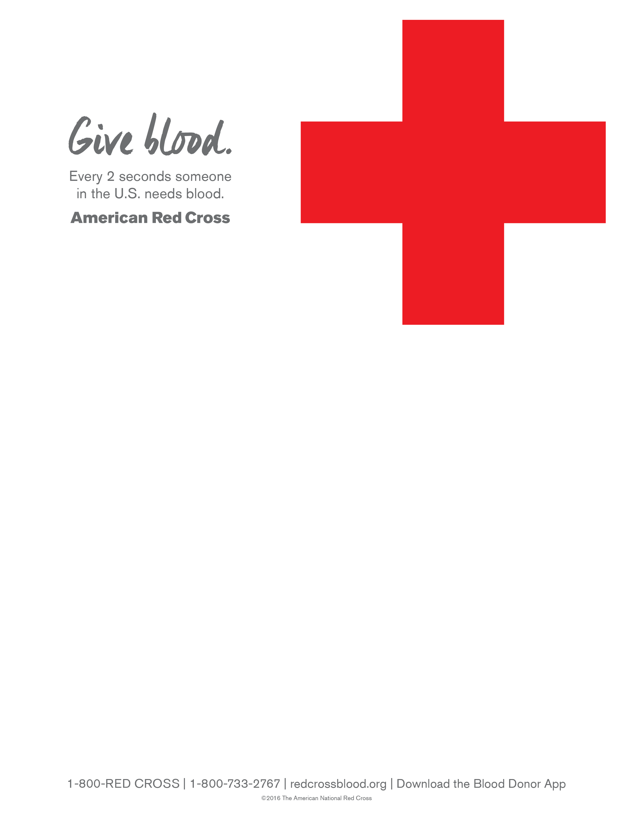
You are Invited to the
Newport Beach City Employee’s Blood Drive

Monday, January 14, 2019
9:00am to 3:00pm

Location: Newport Beach Civic Center
Civic Center Community Room
100 Civic Center Drive, Newport Beach, 92658

To schedule your donation appointment,
Contact Laura at the Red Cross at
laura.rudd@redcross.org or call (949)439-0551
Or sign-up on-line at www.redcrossblood.org
Use sponsor code: NBCivicCenter

