W
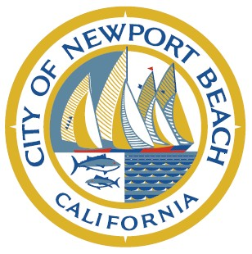

CITY OF NEWPORT BEACH
LIBRARY LECTURE HALL DESIGN COMMITTEE

NOTICE OF CANCELLATION
OF SCHEDULED MEETING

Notice is hereby given that the meeting of the LIBRARY LECTURE HALL DESIGN COMMITTEE scheduled for Monday, APRIL 20, 2020, has been canceled.

The next meeting will be held on MONDAY, May 4 at 1:00 PM in the CRYSTAL COVE CONFERENCE ROOM, located at 100 Civic Center Drive, Newport Beach, CA 92660.

