
CITY OF NEWPORT BEACH

COMMUNITY DEVELOPMENT DEPARTMENT

BUILDING DIVISION
100 Civic Center Drive | P.O. Box 1768 | Newport Beach, CA 92658-8915
www.newportbeachca.gov | (949) 644-3200
2022 SWIMMING POOL & SPA
RESIDENTIAL
MINIMUM CONSTRUCTION REQUIREMENT
ENCLOSURE, BARRIER & DROWNING PREVENTION
- Every pool and/or spa shall be fully enclosed by a barrier. Pool Barrier shall comply with the following (NBMC 15.09, ISPSC 305.2.1 through 305.3.3):
  - 5 ft or greater height above grade, measured from outside of the pool area.
  - Minimum 45 inches spacing of horizontal members when placed on the outside of the fence.
  - Maximum 4 inch spacing of vertical members.
  - Decorative cutouts shall not exceed 1.75 inches wide.
  - Maximum 2 inch vertical clearance between the bottom of the fence and ground.
  - Maximum 1.75 inch square chain link mesh, unless provided with slats fastened at the top and bottom which reduce the openings to 1.75 inches or less.
  - Diagonal members shall form openings of 1.75 inches or less.
  - Gates shall have self-closing, and self-latching mechanisms. Latch mechanism shall be at least 60 inches above the ground.
  - All gates shall swing out of the pool area in the direction leading to a public way.

- Prior to pre-plaster approval and filling pool/spa, at least two drowning prevention safety measure as noted in #3 below shall be permanently installed (CBC 3109.2 (115922)).

- Two drowning prevention safety features shall be provided. Identify the drowning prevention safety feature to be utilized for this pool installation (CBC 3109.2 (115922)).
  - Intermediate pool enclosure between the house and pool.
  - Removable mesh pool fencing that meets American Society for Testing and Materials (ASTM) Specifications F2286 standards in conjunction with a gate that is self-closing and self-latching and can accommodate a key lockable device.
  - All doors providing direct access to the pool/spa area from the residence shall be equipped with a self-closing, self-latching device with a release mechanism placed at 54 inches or more above the floor.
  - The residence shall be equipped with exit alarms on all operable windows having a sill height of less than 48 inches above the indoor finished floor or doors providing direct access to the pool/spa. Alarms shall comply with the following:
    - Alarms shall be listed and labeled in accordance with UL 2017. (CBC 3109.4.1.8 Item 1).
    - Alarm shall produce an audible warning when the door and/or its screen, are opened.
    - The alarm shall sound continuously for a minimum of 30 seconds within 7 seconds after the door is opened, at a sound pressure level of not less than 85 dBA when measured inside the dwelling at 10 ft from the alarm.
    - The alarm shall automatically reset under all conditions.
    - The alarm shall be equipped with a manual means to temporarily deactivate the alarm for a single opening. The deactivation shall last not more than 15 seconds. The deactivation switch shall be located at least 54 inches above the threshold of the door.
    - Alarms shall be permanently secured by screws or epoxy.
  - An ASTM Specifications F1346-91 (reapproved 2010) approved safety pool cover.
    - Product Manufacturer:
    - Product Name:
    - ASTM listing agency approval letter.
  - Swimming pool alarms that, when placed in pools, will sound upon detection of accidental or unauthorized entrance into the water. These pool alarms shall meet and be independently certified to the ASTM Standard F2208 “Standards Specification for Pool Alarms” which includes surface motion, pressure, sonar, laser and infrared type alarms. For purposes of this article, “swimming pool alarms” shall not include swimming protection alarm devices designed for individual use, such as an alarm attached to a child that sounds when the child exceeds a certain distance or becomes submerged in water.

- Safety glazing is required in fences, doors and windows, where the glass is within 5 ft of the pool/spa/hot tub’s edge and less than 60 inches above grade (CBC 2406.4.5 & CRC R308.4.5).

- The construction sites for in-ground swimming pools and spas shall be provided with construction fencing to surround the site from the time that any excavation occurs up to the time that the permanent barrier is completed. The fencing shall be not less than 4 feet in height. (ISPSC 305.1.1)

POOL AND SPA CONSTRUCTION
- Construction of stairs into the shallow end and recessed pool stairs shall conform to the following (ISPC 809.5):
  - Treads shall have a minimum unobstructed horizontal depth of 10 inches and a minimum unobstructed walking surface area of 240 square inches.
  - Risers, other than the top and bot-tom riser, shall have a uniform height of not greater than 12 inches.
  - The top riser height shall be any dimension not exceeding 12 inches for the width of the walking surface.
  - The bottom riser height shall be any dimension not exceeding 12 inches.
  - Riser heights shall be measured at the horizontal centerline of the walking surface area.
  - In design water depths exceeding 48 inches, additional steps shall not be required.
- The slope of beach and sloping entries used as a pool entrance shall not exceed 1 unit vertical in 7 units horizontal (14-percent slope). (ISPC 809.6)
- Where steps and benches are used in conjunction with sloping entries, the vertical riser distance shall not exceed 12 inches. For steps used in conjunction with sloping entries, the requirements of Section 809.6 shall apply. (ISPC 809.7)
- The horizontal surface of underwater seats, benches and swimouts shall be not greater than 20 inches below the design waterline. (ISPC 809.9)
- SPA FLOOR: The slope of the floor shall not exceed 1 unit vertical in 12 units horizontal (8.3-percent slope). Where multilevel floors are provided, the change in depth shall be indicated. (ISPC 503.3, 901.2)
- Where installed, steps and ladders shall be located outside of the minimum diving water envelope as indicated
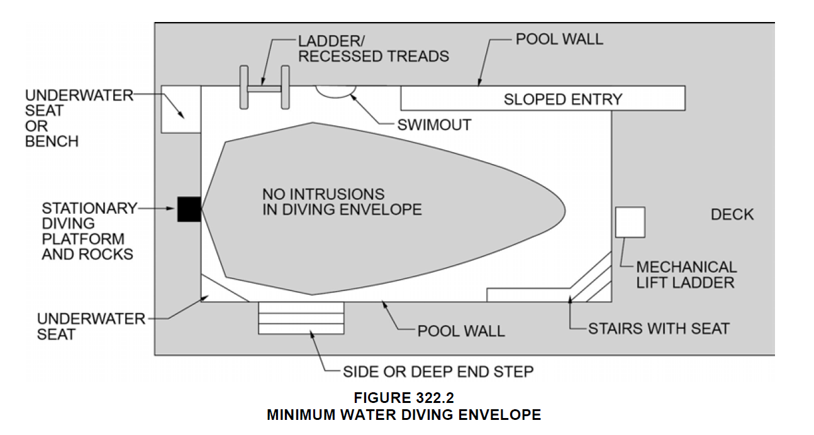
- LADDERS: Ladder treads shall have a uniform horizontal depth of not less than 2 inches. There shall be a uni-form distance between ladder treads, with a distance of not less than 7 inches and not greater than 12 inches. The top tread of a ladder shall be located not greater than 12 inches below the top of the deck or coping. Ladder treads shall have slip-resistant surfaces. (ISPC 322.3)
  - There shall be a clearance of not less than 3 inches and not greater than 4 inches between the pool wall and the ladder.
  - Ladders shall be provided with two handholds or two handrails. The clear distance between ladder handrails shall be not less than 17 inches and not greater than 24 inches.
- RECESSED TREAD: Recessed treads shall have a mini-mum depth of not less than 5 inches and a width of not less than 12 inches. The vertical distance between the pool coping edge, deck, or step surface and the uppermost recessed tread shall be not greater than 12 inches. Recessed treads shall have slip-resistant surfaces. (ISPC 322.4)
  - Recessed treads at the center-line shall have a uniform vertical spacing of not less than 7 inches (178 mm) and not greater than 12 inches.
  - Recessed treads shall drain into the pool.
  - Recessed treads shall be provided with a handrail or grab rail on each side of the treads. The clear distance between handrails and grab rails shall be not less than 17 inches and not greater than 24 inches.
- HANDHOLDS: Where the depth below the design waterline of a pool or spa exceeds 42 inches, handholds along the perimeter shall be provided. Hand-holds shall be located at the top of deck or coping (ISPSC 323.1).
  - Handholds shall be located not more than 12 inches above the design waterline.
  - Handholds shall be horizon-tally spaced not greater than 4 feet apart.

ELECTRICAL SYSTEM
- Any walk surface within 3 ft of the pool edge shall be bonded, including unreinforced or landscaped areas. (CEC 680.26.(B)(2))

- In outdoor pool areas, luminaires, lighting outlets, and ceiling-suspended (paddle) fans installed above the pool or the area extending 5 ft. horizontally from the inside walls of the pool shall be at a height not less than 12 ft. above the maximum water level of the pool. (CEC 680.22.(B)(1)).

- Electrical outlets less than 20 ft from pool or spa shall be GFCI protected (CEC 680.22.(A)(4)).

- All overhead power lines and other services shall comply with CEC 680.9.

- The following devices and equipment associated with the swimming pool, spa, or hot tub shall be grounded in accordance with CEC, Article 680.6:
  - Underwater Lighting
  - Electrical equipment and panel boards
  - Ground fault circuit interrupters

- The following structures and equipment shall have electrical bonding (CEC 680.26):
  - Pool shell reinforcing or metal shell
  - Underwater lighting
  - Metal fittings attached to pool structure
  - Electrical equipment including pumps, motors, & electric pool covers
  - Fixed metal parts/structures (i.e. metal sheathed cables, pipings, awnings, fences, etc…) less than 5 ft horizontally measured from inside pool wall
  - Fixed metal parts/structures (i.e. metal sheathed cables, pipings, awnings, fences, etc…) less than 12 ft vertically above highest water level
  - Steel reinforcing under adjacent walking surfaces

- The following devices and equipment associated with the swimming pool, spa, or hot tub shall be GFCI protected in accordance with CEC Section 680:
  - Receptacles located within the general area of a pool, spa, or hot tub
  - Receptacles used for power generation for pools, spas, and hot tubs
  - Electrical equipment

PLUMBING & HEATING SYSTEMS
- Pool system piping (CA-ENERGY 150(p)(2)):
  - A straight pipe (min. length = 4 x pipe diameter) shall be installed before the pump.
  - Pipe size shall be sized such that at maximum flow the velocity of the water is less than 8 fps in the return line and 6 fps in the suction line.
  - All elbows shall be of sweep elbow or elbow-type that provides less pressure drop than straight pipe length of 30 pipe diameter.
  - Pool filters shall be at least the size specified in NSF/ANSI 50 for public pool intended applications. (CA-ENERGY 150(p)(3))
  - Backwash valve shall be same as return pipe diameter, but not less than 2” diameter. (CA-ENERGY 150(p)(4))

- Pool/spa drain shall be connected to a “P” trap, which drains to the sewer system. (CPC 813.1)

- Pool/spa heater vent shall be 4 ft away from property line. The equipment vent shall be 4’ away or one foot above openings in dwelling exterior walls. (CMC 802.8.2)

- Where equipment, including pool/spa equipment such as pumps, filters and heaters, is on the same lot as a pool or spa and such equipment is located outside of the barrier protecting the pool or spa, such equipment shall be located not less than 36 inches from the outside of the barrier. (ISPSC 305.2.9)

- Pool/spa heating system shall be certified by the manufacturer for the following items (CA-ENERGY 110.4(a)):
  - For equipment subject to State or federal appliance efficiency standards, listings in the Commision’s directory of certified equipment showingng compliance with applicable standards
  - On-off switch mounted outside of the heater
  - A permanent weatherproof instruction plate or card for energy efficient operation
  - No electric resistance heating

- Waste water from any filter, scum filter, scum gutter, overflow, pool emptying line, or similar apparatus shall discharge into an approved type receptor and subsequently into a public sewer. The flood level rim of such receptor shall be at least 6 inches above the Base Flood Elevation (BFE) indicated in the Flood Insurance Rate Map (FIRM) as printed by the Federal Emergency Management Agency’s with effective date of 3-21-2019. Direct connections shall not be made between the end of the backwash line and the disposal system. Drains shall discharge through an air gap. (ISPSC 320.1)

- New swimming pool/spa shall have at least two circulation suction outlets per pump that shall be hydraulically balanced and symmetrically plumbed through one or more “T” fittings, which are separated by a distance of at least 3 ft in any direction between the drains. (CBC 3109.2 (115928)(a)(2))

- Suction outlets shall be covered with anti-entrapment grates, as specified in the ANSI/APSP-16 performance standard or successor standard designated by the federal Consumer Product Safety Commission that cannot be removed except with the use of tools. Slots or openings in the grates or similar protective devices shall be of a shape, area, and arrangement that would prevent physical entrapment and would not pose any suction hazard to bathers. (CBC 3109.2 (115928.(b)))

- Surface skimming systems shall be listed and labeled in accordance with NSF 50.

PUMPS & MOTORS
- An emergency shutoff switch shall be provided to disconnect power to recirculation and jet system pumps and air blowers. Emergency shutoff switches shall be: provided with access; located within sight of the pool or spa; and located not less than 5 feet horizontally from the inside walls of the pool or spa.

- All pool or spa systems and equipment shall have the following (CA-ENERGY 110.4):
  - At least 36 inches of pipe between the filter and heater, or dedicated suction and return line, or built-in connection to allow for the future addition of solar heating equipment.
  - A cover for outdoor pools or spas if a heat pump or gas heater is used.
  - Pool shall have directional inlets to mix the pool water.
  - The circulation pump must have a time switch that allows the pump to be set to run in the off-peak electric demand period for the minimum time required to maintain public health standards.

- Pool pumps & motors (CA-ENERGY 150(p)(1)):
  - Only those listed in the Commission’s directory of certified equipment shall be installed
  - Filtration flow rate shall not exceed that to turn over pool water volume in 6 hours or 36 gpm, whichever is greater.
  - Pump motors (for filtration) shall meet the applicable federal standard in 10 CFR 431.465.
  - Each auxiliary pool load (spa, water features, etc.) shall be served by a separate pump or multi-speed pump.
  - Multi-speed pump shall have controls that will default to the filtration flow rate when no auxiliary pool loads are operating.
  - Multi-speed pump shall default to the filtration flow rate setting within 24 hours.

INSPECTION
- Special inspection is required for shotcrete and gunite installation.

- A sound test by an acoustical engineer is required to demonstrate that the noise level from the pump is less than 55 dBA at the property line. NBMC 10.26.025.

- Where sulfate or salt water exposure is known to exist due to local soil conditions, concrete shall be of Type V and shall have a compressive strength of 4500 psi min at 28 days. Epoxy coated reinforcing bars shall be required for all shell reinforcing and bond beam bars.

SOUTHERN CALIFORNIA EDISON SETBACK
- Overhead Electric Line Construction General Order No. 95, Section V Detailed Construction requirements for supply lines. 54.4-A3
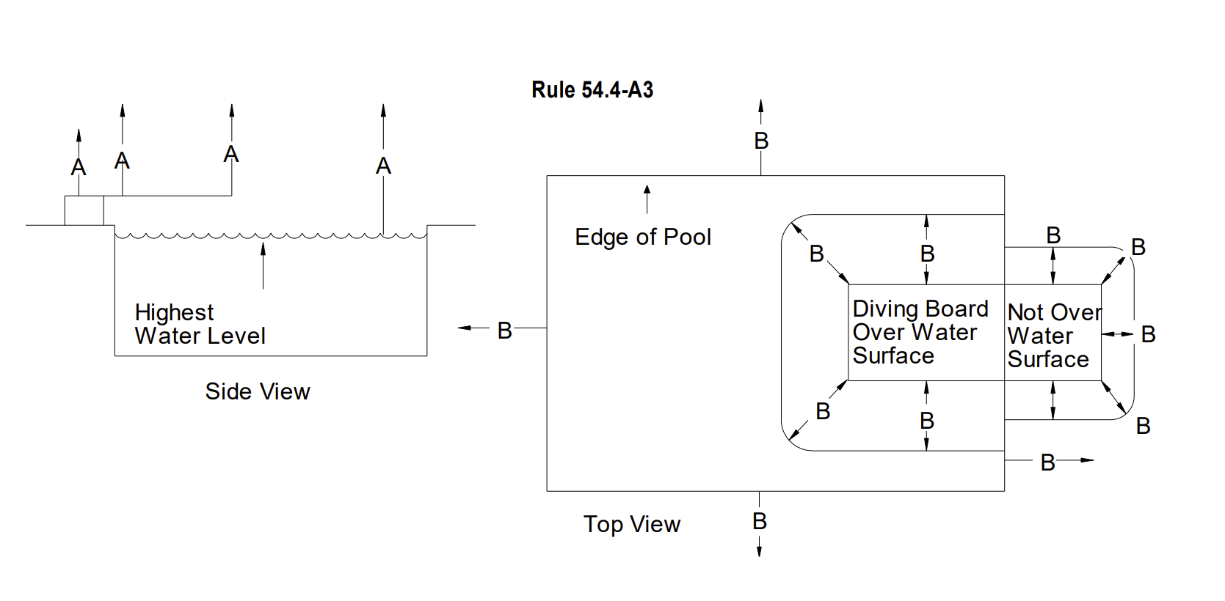
Clearance Over Swimming Pools
Figure 54-1

Minimum Vertical and Radial Clearances over Swimming Pools | A  Minimum  Vertical | B  Minimum  Radial
Unprotected Line Conductors (Vertical Over Highest Water Level and Radial from Top Edge of Pool Walls)  - 0 - 750 Volts  - 750 - 22,500 Volts  - 22.5 - 300 kV | 20 Feet  25 Feet  30 Feet | 20 Feet  25 Feet  30 Feet
Service Drops (Vertical Over Highest Water Level and Radial from Top Edge of Pool Walls  - Pools Residential  Service Drops (Over Diving Boards or Platforms)  - Portion of Board or Platform That is Over Water Surface  - Portion of Board or Platform That is not Over Water Surface | 12 Feet  16 Feet  12 Feet | 12 Feet  8 Feet  3 Feet
Guys (Ungrounded Portions)  - Over Highest Water Level and from Top Edge of Pool Walls  - Over Diving Board or Platform (The Portion that is Over the Water Surface)  - Over Diving Board or Platform (The Portion that is not Over the Water Surface) | 18 Feet  18 Feet  12 Feet | 18 Feet  8 Feet  6 Feet
Guys (Grounded Portions)  - Over the Highest Water Level  - Over Diving Board or Platform (The Portion that is Over the Water Surface)  - Over Diving Board or Platform (The Portion that is not Over the Water Surface) | 16 Feet  16 Feet  8 Feet | -  8 Feet  3 Feet

