W
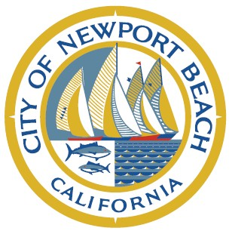

CITY OF NEWPORT BEACH
WATER QUALITY/COASTAL TIDELANDS COMMITTEE

NOTICE OF CANCELLATION
OF REGULARLY SCHEDULED MEETING

Notice is hereby given that the regular meeting of the WATER QUALITY/COASTAL TIDELANDS COMMITTEE scheduled for
THURSDAY, March 4, 2021 has been canceled.

The next regular meeting will be held on THURSDAY, April 1, 2021 at 3:00 PM location to be determined.

